Website to check all the information of apps
https://fishinfos.xyz/

Lorem Ipsum is simply dummy text of the printing and typesetting industry. Lorem Ipsum has been the industry standard dummy text ever since the 1500s, when an unknown printer took a galley of type and scrambled it to make a type specimen book. It has survived not only five centuries, but also the leap into electronic typesetting, remaining essentially unchanged. It was popularised in the 1960s with the release of Letraset sheets containing Lorem Ipsum passages, and more recently with desktop publishing software like Aldus PageMaker including versions of Lorem Ipsum.

1.Article Rewriter
2.Plagiarism Checker
3.Backlink Maker
4.Meta Tag Generator
5.Meta Tags Analyzer
6.Keyword Position Checker
7.Robot.txt Generator
8.XML Sitemap Generator
9.Backlink Checker
10.Alexa Rank Checker
11.Word Counter
12.Online Ping Website Tool
13.Link Analyzer
14.My IP Address
15.Keyword Density Checker
16.Google Malware Checker
17.Domain Age Checker
18.Whois Checker
19.Domain into IP
20.URL Rewriting Tool
21.www Redirect Checker
22.URL Encoder/Decoder
23.Server Status Checker
24.Webpage Screen Resolution Simulator
25.Page Size Checker
26.Reverse IP Domain Checker
27.Blacklist Lookup
28.Suspicious Domain Checker
29.Link Price Calculator
30.Website Screenshot Generator
31.Domain Hosting Checker
32.Get Source Code of Webpage
33.Google Index Checker
34.Website Links Count Checker
35.Class C Ip Checker
36.Online Md5 Generator
37.Page Speed Checker
38.Code to Text Ratio Checker
39.Find DNS records
40.What Is my Browser
41.Email Privacy
42.Google Cache Checker
43.Broken Links Finder
44.Search Engine Spider Simulator
45.Keywords Suggestion Tool
46.Domain Authority Checker
47.Page Authority Checker
48.Pagespeed Insights Checker

10 amazing and killer facts about DARK WEB
June 20, 2019
TEN AMAZING and KILLER FACTS ABOUT DARK WEB
Welcome to FACE THE TECH
I think you might be very excited to know killer facts about dark web . what if you can enter it the dark web which is approximately *10 times larger than safe web click here to know how to enter
Before that lets know the amazing,dangerous and killer facts about the dark web
1. IS IT SAFE OR SCAM
As you all know Internet is a two edged knife. so dark web you can gain enormous and detailed knowledge of everything at one edge and addictive and bad information on other edge .
SAFE CONTENT = 50% SCAM CONTENT = 50%
2. WHAT WE CAN FIND IN DARK WEB
Everything! This sounds crazy but its the truth.
- KNOWLEDGE FORUMS
- FINANCIAL SERVICES
- HACKING
- DRUGS
- WEAPONS
- BIT COIN
- CHEAP PRODUCTS
- HIT MAN SERVICES

3. DO HACKING REALLY HAPPENS IN DARK WEB
My Answer is a big YES

It Really happens in dark web. I can further say dark web is paradise to hackers because they can find target victims who enters dark web to buy credit cards or hire some one to hack . Hackers do target these visitors and earn from them and its not always secure some hackers earn money doing DDOS attacks on other bank accounts and websites and demand money
According to me only some websites provide original services it is very hard to find them.
4. HOW TO ENTER DARK WEB
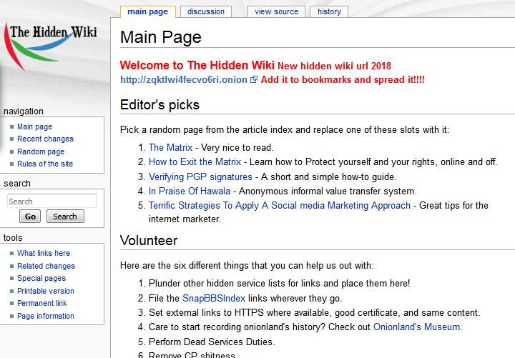
- INSTALL TOR BROWSER
- http://hiddenw3s6tmzdwo.onion/wiki/index.php?title=Main_Page
- THIS IS THE OFFICIAL PAGE OF ALL FAMOUS WEBSITES
- GO THROUGH THEM AND BROWSE SAFELY
- DON'T PAY A SINGLE PENNY UNLESS YOU KNOW ABOUT IT

5.WHAT IS TOR BROWSER WHY DARK WEB LINKS OPENS IN IT ONLY
Had U Ever seen an ONION. how it looks like inside it contains several pores to reach middle of it


Exactly tor browser also provides so many layers to reach the user if some one wants to track you


6. DUCK DUCK GO
you had reached this famous blog from google which tracks you but duck duck go doesn't track you. we cant find .onion links in google but we often can find .onion links in duck duck go thats why duck duck go is default search engine in tor browser

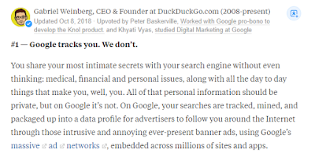

7. KALI LINUX - HACKING SOFTWARE
It is an OPERATING SYSTEM like windows os but it provides various tools which are used in hacking most of the hackers initiate their hacking from this software this is very anonymous which is built by professionals
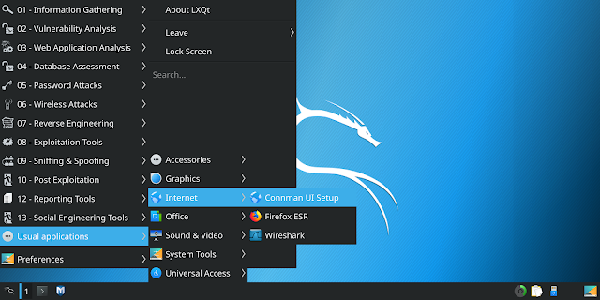

IT PROVIDES IN BUILT-IN TOOLS LIKE
- INFORMATION GATHERING
- VULNERABILITY ANALYSIS
- WEB APPLICATION ANALYSIS
- DATABASE ASSESSMENT
- PASSWORD ATTACKS
- WIRELESS ATTACKS
- REVERSE ENGINEERING
- EXPLOITATION TOOLS
- SNIFFING & SPOOFING
- POST EXPLOITATION
- REPORTING TOOLS
- SOCIAL ENGINEERING TOOLS
8. DDOS ATTACKS

we often hear the news about websites being hacked . the reason behind those attacks is DDOS(distributed denial of service attack)
how websites face DDOS attacks

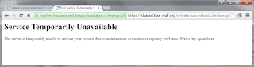
- HACKER SELECT THE TARGET WEBSITE
- HE INFLOW A HIGH AMOUNT DATA TRAFFIC TO THAT SITE
- WHEN THE SITE EXPERIENCES HIGH TRAFFIC IT CRASHES
- IT CAUSES A LOT DAMAGE TO BANKING WEBSITES AND SHOPPING WEBSITES

9. RANSOMWARE ATTACKS
It is a subset of malware which locks all the system data and encrypts all files hackers demand money to decrypt the information the famous and recent attack wanna cry is a ransomware.if we failed to pay the money intime the total files will be lost . we need to send the money in BITCOIN
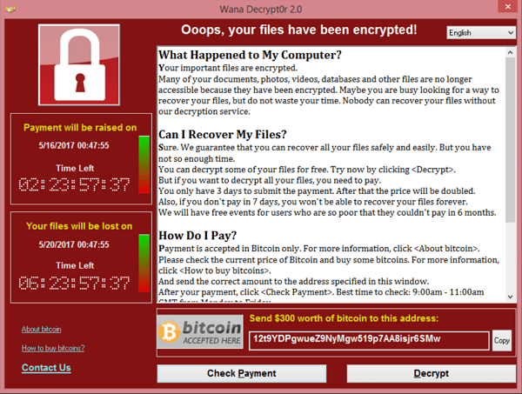

10. BITCOIN
Every county has its own currency so hackers do .bitcoin is a virtual type of currency which has grown tremendously in recent time over 300% . hackers demand money to be transferred in bitcoin(btc) which cant be traced every account has its unique code to transfer the amount



Udemy course free, without any charges How? - Face the Technology Guide
June 19, 2019

HOW TO GET UDEMY COURSES FOR FREE
Udemy is an online learning platform that aims the professional adults. Udemy courses are just to improve job-related skills and are not under the credential for college credits. So today we will learn how to get the udemy courses for free with a simple process.
Given below are the steps to get the udemy courses for free -

1. Open your browser and type udemy.com
To get the course firstly open the website- www.udemy.com
2. Just copy the name of the course to watch online
A window will open and there copy the name of the course you want to watch online.
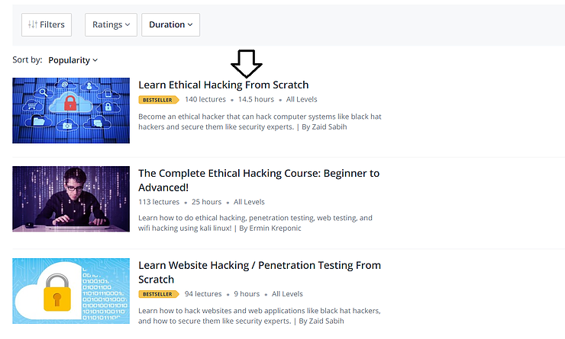

3. Open pirate bay

Now open the pirate bay website.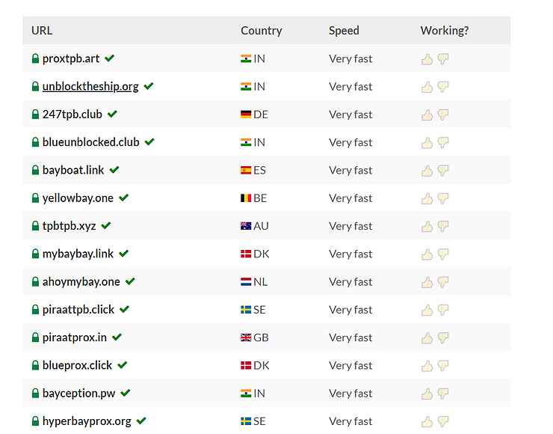
4. Click on the first link proxtbp.art and it will redirect to the pirate search engine. Paste the name of the course you want to watch by adding udemy in front of it.
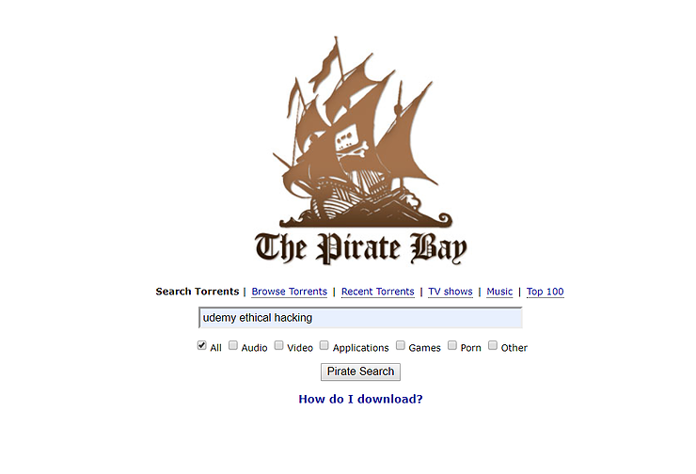

5. Select the most relevant topic you searched for.
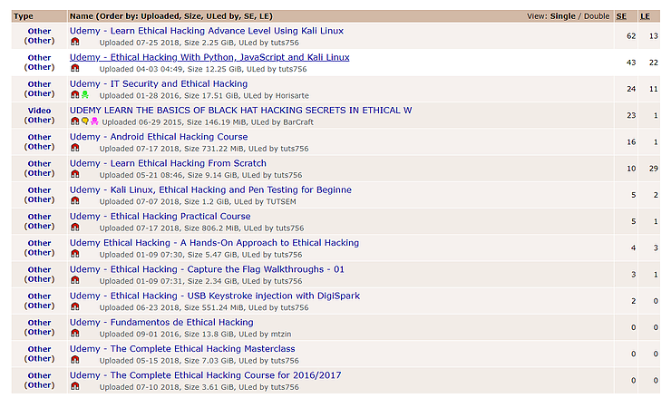

6. Click on the .torrent link
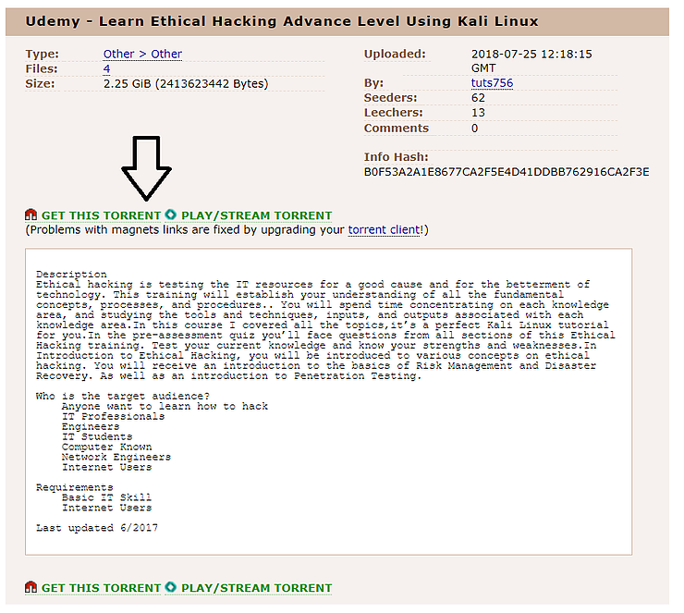

7. It will redirect to bitlord page and now you can download the torrent software
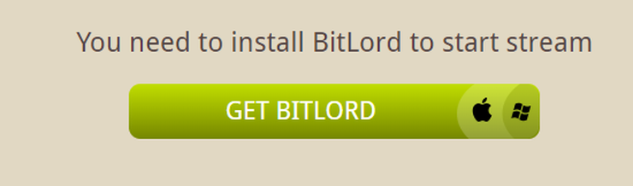

8. Download the software to start the course online
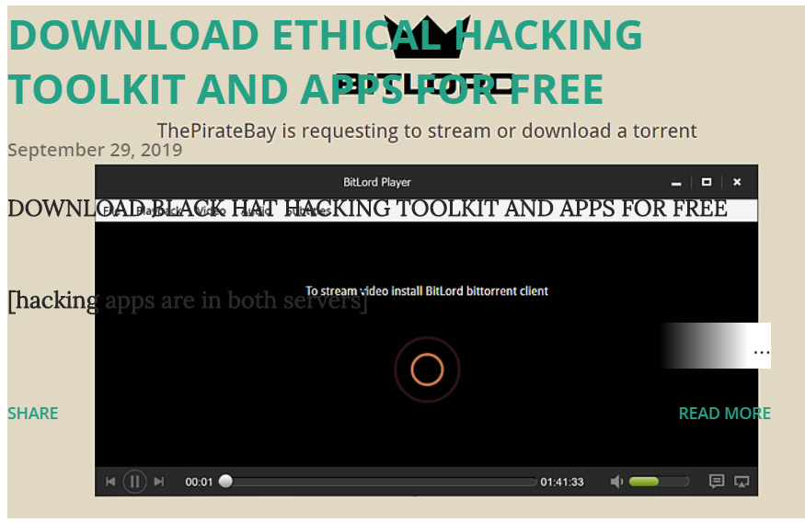

I THINK YOU HAD KNOWN ALL ABOUT DARK WEB.KINDLY GIVE ANY SUGGESTION OR COMMENT ABOUT THIS POST AND SEND THE POST LINK TO YOUR FRIENDS
- BS DHEEMANTH REDDY

